TABLEAUX VIVANTS

This lesson was carried out on November 2023, during the students’exchange in Catania - Italy, within the Erasmus+ Project “A different view of the world”.
In that week students focused on several activities involving photography.
This lesson took place in Ortigia- Siracusa, on the 28th of November . Students were divided into groups in order to pose for different tableaux vivants, each one reproducing famous paintings and iconic scenes from movies, music and pop culture.

Objectives: this lesson was meant to offer the participating students further opportunities to cooperate on a common task, elaborating their own final output and working all together, exchanging their ideas and opinions in English, to achieve a shared goal and to learn and improve techniques relating to photography.

Students worked on:
- paintings depicting several characters
- Iconic scenes from movies
- Iconic images from music and pop culture

Subject: Art

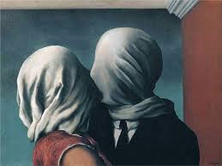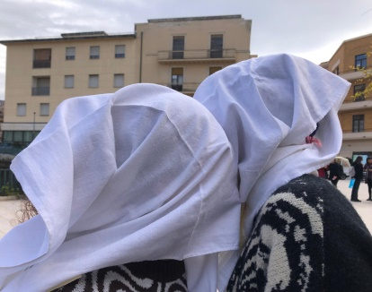

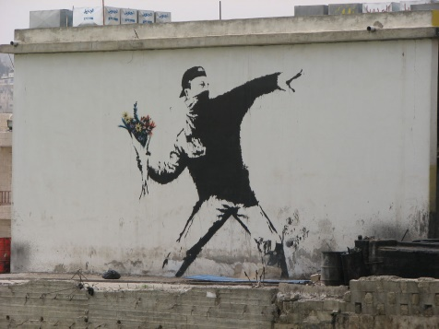
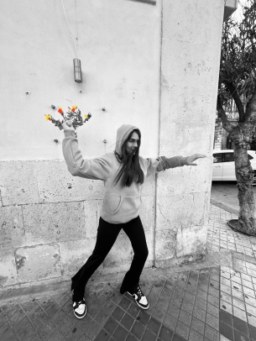
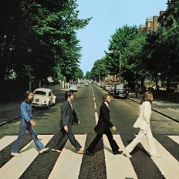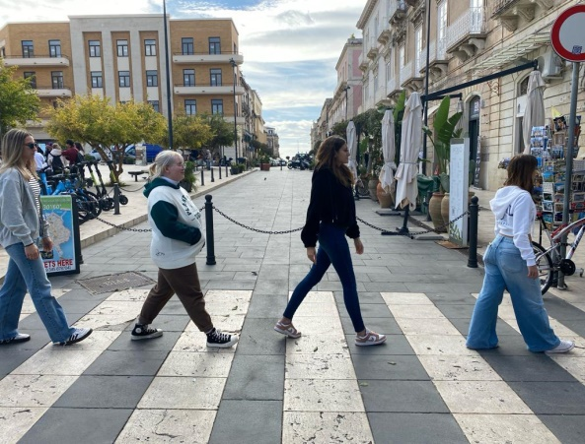


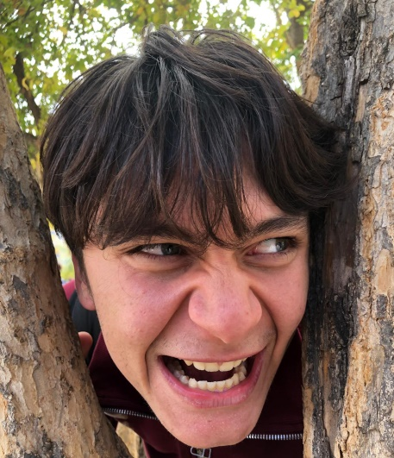

Lesson Plan:

Number of participants: 40
Age: 16-17
Duration: 2 hours
Tools: smartphones, cameras.

Step | Time (2 hours) | Activity | Interaction | Purpose
Engage | 10 minutes | Presentation of the project and instructions to the students.  Presentation and analysis of the work/s the students will be working on.  (Teachers explains the feelings of the depicted characters and the way they interact with each other and with the environment around them) | T - Ss | Presentation of the project and its objectives.  Presentation of the paintings and iconic scenes to be reproduced by the students.
Study | 20 minutes | Further details concerning the expected output and how to achieve it.  Presentation of similar creations. The students start thinking about how to reproduce the work they have chosen or been assigned, what materials they need to find, how they will what materials they need to find, how they will perform it, etc. | T – Ss  Ss - Ss | Analyzing examples of similar creations online.  Exchanging ideas and opinions in English  Working and cooperate on a common task.
Activate | 1 hour | The students decide on the different roles each of them will take over. They start rehearsing their different parts and complete their task, also applying what they have learnt about photography while taking photos. | Ss | Learn and improve techniques relating to photography.  Achieve a shared goal and working on a final output.
Follow up | 30 minutes | A spokesman for each group presents what they have wished to convey in their work and how. | T – Ss  Ss – Ss | Presentations of all the final works.

