LOOK AND SNAP!
Emotions between art history and photography.
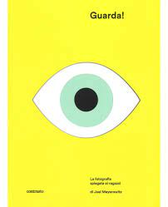
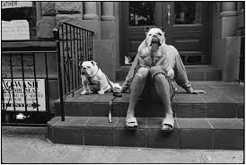

Through the works exhibited in the exhibition Rievolution, at the Palace of Culture in Catania, the educational workshop Look and shoot! Emotions between art history and photography aims to introduce students to the world of emotions through contemporary Italian art and interacting with photography. To do this they will be asked to use the camera of their own smartphone, an object too often demystified and enemy, from which it is increasingly difficult to detach and that here will become, instead, a device to recognize emotions by appreciating photography and producing meaningful images.
After a brief explanation on the type of works exhibited at the exhibition, some suggestions on photography taken from the text Look! The photography explained to the children by Joel Meyerowitz, which will allow the students to understand what is in photography «intuition, timing, point of view, patience in waiting and courage to approach», continuing with some suggestions from the great photographers, Like Henri Cartier Bresson, the pupils will be given a sheet that will contain the name of an emotion and its meaning and they will be invited to search for it within the exhibition among the works exhibited and represent it through their shot.
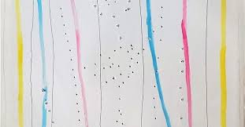

As a couple, the students will be oriented, in fact, inside the exhibition halls and between the works and looking for an image of the emotion, interacting with themselves and among themselves. They will have to make different types of photo shots:
- The selfie
- The portrait
- the report
- the landscape
- the abstract
Pistoletto’s mirrored surfaces, street art works, the works of the Futurists, examples of abstract and kinetic art and the same spaces of the staging that they themselves will animate as background, as a stimulus and a colour palette for the search of emotion that can be represented through a particular photograph or several shots, post produced or not by themselves, supporting in the first place the intimate desire to tell and tell within an emotion. The last step of the workshop will be a moment of sharing where everyone can see the 'excited shots' of the companions, recognize them, associate them and compete to guess them.

Number of participants: 40
Age: 16-17
Duration: 2 hours
Instrumentation: smartphone, fantasy, silence and ... emotion!

