DISCOVERING NATURE
This lesson was carried out on November 2023, during the students’exchange in Catania - Italy, within the Erasmus+ Project “A different view of the world”.
In that week students focused on several activities involving photography.
This lesson took place during an excursion on the Volcano Etna, on the 30th of November . Students were divided into groups in order to look for, collect and identify leaves of plants and trees belonging to the flora of the volcano.

Objectives: this lesson was meant to offer the participating students further opportunities to cooperate on a common task working all together, exchanging their ideas and opinions in English, to achieve a shared goal, to learn and improve techniques relating to photography, to learn about nature and the vegetation on the Volcano Etna.

Subject: Biology

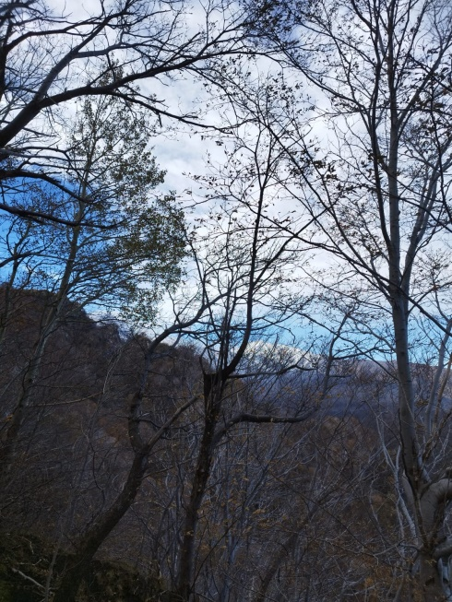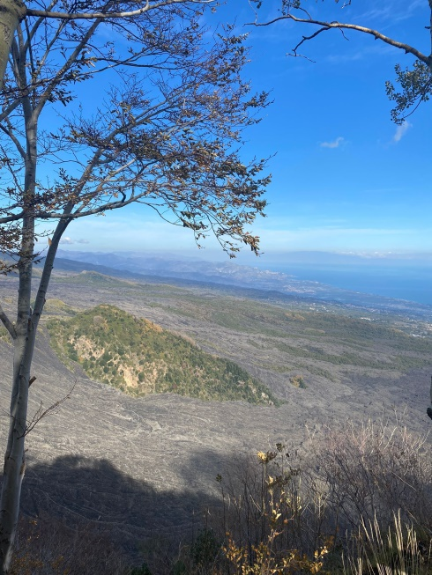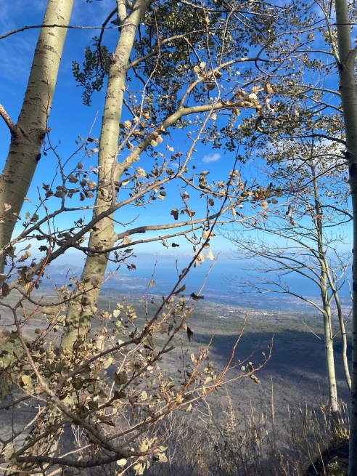

Lesson Plan:

Number of participants: 40
Age: 16-17
Duration: 2 hours
Tools: a handout showing some leaves and the name of the plants and trees they belong to; a pencil ; smartphones, cameras

Step | Time (2 hours) | Activity | Interaction | Purpose
Engage | 10 minutes | Presentation of the project and instructions to the students.  Presentation and analysis of the task.  (The biology teacher gives each group of students a handout showing some leaves and the names of the plants they belong to, in order to collect them ) | T - Ss | Presentation of the project and its objectives.  Presentation of the leaves that students will have to collect during the excursion.
Study | 20 minutes | Further details concerning the expected output and how to achieve it.  Presentation of the vegetation of the Volcano Etna. The students start thinking about how to identify the leaves and how to take good photos showing the details of the leaves and the plants and trees they belong to, in order to classify them. | T – Ss  Ss - Ss | Analyzing details of leaves and plants.  Knowing the vegetation of the mount Etna  Exchanging ideas and opinions in English  Working and cooperate on a common task.
Activate | 1 hour | The students decide on the different roles each of them will take over within the groups (look for, collect, taking photos, classify etc.). They start looking for leaves and collecting them. They complete their task, also applying what they have learnt about photography while taking photos. | Ss | Learn and improve techniques relating to photography.  Learning about the vegetation of the Volcano Etna.  Achieve a shared goal and working on a final output.
Follow up | 30 minutes | A spokesman for each group presents the leaves they have found and the corresponding photos and say if they have found all the leaves showed in the handout. | T – Ss  Ss – Ss | Presentations of all the final works and choice of the winner (number of leaves found + best photos)

