Cyanotype lesson

Lesson duration: 2 hours

SKILLS | EXPERIENCES & OUTCOMES | THEMES | AREA
Digital/photography | Explore media | Natural environment | Design
Drawing & Painting | Use visual elements | Storytelling/ fantasy/ imagination | Expressive
Printmaking | Observe &  record | history
 | Analyse and discuss

Create flowers scenes using Cyantotype. Cyanotype is a basic form of photography and a great introduction into how photography works.

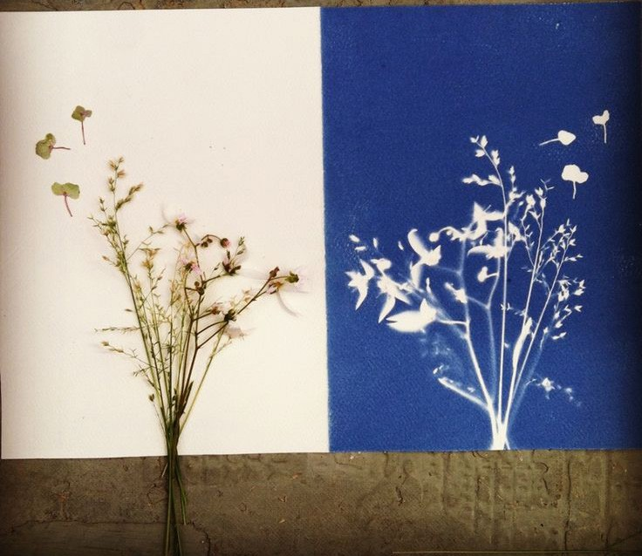

Materials that can be used for cyanotyping:

You can use these materials for cyanotype without the need for special treatments as well as sanding and subsequently applying more than one pass of the chemical solution.

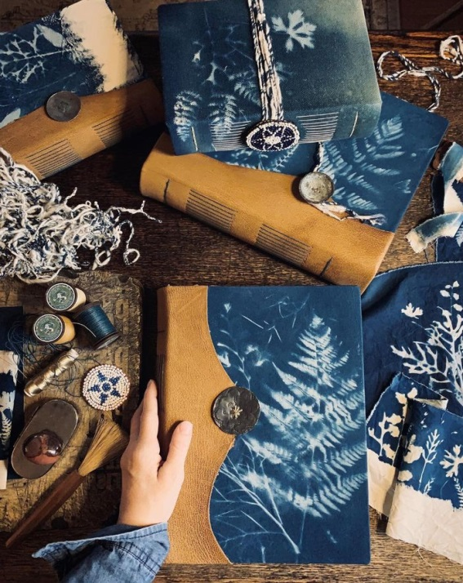
*paper (better if with high absorbent capacity)
*fabric;
chalk or clay;
*ceramics (first firing in a ceramic kiln);
*untreated wood;
*stones.

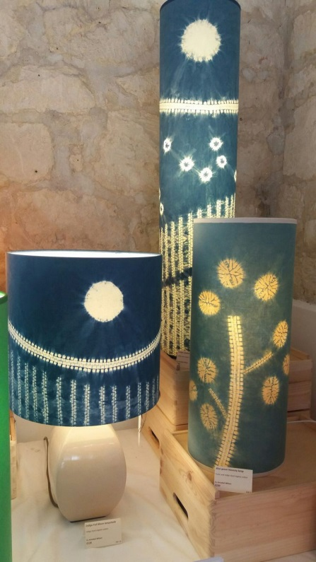
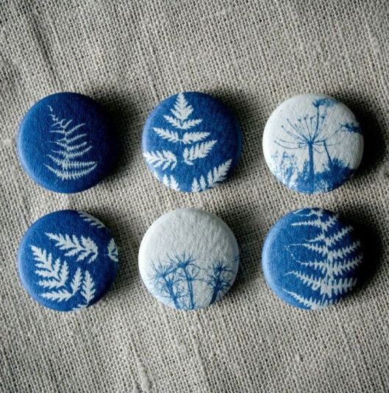

MATERIALS TO CREATE YOUR OWN CYANOTYPES

CYANOTYPE SOLUTION

for a 200 ml solution
* Solution A 20 g of ammonium ferric citrate
*Solution B 8 g of potassium ferricyanide
* Recipients for each solution
* Syringe
*200 ml of water
Introduction and input:
We will be using the Cyanotype technique to create photo prints. Use an example sheet of Nature Print paper to demonstrate how it works by taking it outside, placing a cut-out or piece of netting on top to block out areas of light. Follow pack instructions.

Explain that the areas the light couldn’t reach are when you can see the design on the print.

Useful vocabulary: ‘masked’: areas blocked from sunlight

Main Activity:
1. Give each student a sheet of acetate and a marker pen so they can begin to draw their design. Ask them to think about the nature, wood, flowers, leaves…

2. Once the acetate natural landscape is finished, pupils can begin to arrange their design. Firstly, make sure that the classroom is as dark as possible – the paper will begin to develop as soon as it is exposed to light.

3. Give each pupil a sheet of cardboard to use as a sturdy base to keep their artwork on. Lay the Nature print paper flat on top of the card- board and begin to arrange the creature cut-outs and any other flat objects on top.

4. Then place the acetate design on top to sandwich the cut-outs in between the Nature Print paper and the acetate and secure to the card- board using bulldog clips.

5. Bringing the tub of water outdoors with you, find a sunny spot for exposing the prints. They should develop in the sun for two minutes and then submerge the Nature Paper straight away in the water for one minute to stop them becoming over exposed.

6. Dry the prints in the classroom and press under something heavy once dry to flatten out.

Plenary:

First/Second: Examine the dried prints and discuss the science behind the process:

The Sun Sensitive Paper is coated with light-sensitive chemicals, which react to light waves and particles when exposed to light. When you place objects on the paper, they block the light and turn white while the paper around them remains blue. Water stops the process and fixes your images on the paper.

Which areas will be left blue?
What would happen if left in the sun too long?
What would happen if not left in the sun long enough?

